Join a CTE student organization to:
- Learn more about careers, and about post-high school education and training options
- Develop leadership skills that will prepare you for college and career
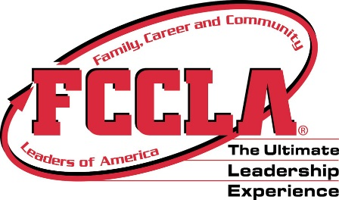
- Test your skills at state or national competitions
Family, Career and Community Leaders of America provides personal growth, leadership development, and career preparation opportunities for students in Family and Consumer Sciences education. Focusing on the multiple roles of family member, wage earner and community leader, members develop skills for life through: character development, creative and critical thinking, interpersonal communication, practical knowledge, and career preparation.
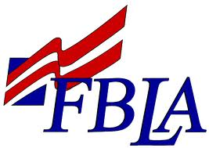
Future Business Leaders of America is an educational association for students who are interested in learning more about the free enterprise system. The purpose of FBLA is to prepare members for careers in business and to assist them by becoming better employees and citizens. FBLA helps students develop leadership abilities, prepares them for entry into a business-related occupations, and offers a setting where members compete at regional, state and national levels in business and technology curriculum.

DECA prepares emerging leaders and entrepreneurs for careers in marketing, finance, hospitality and management. Through participation in DECA activities, members learn how to communicate thoughts and ideas, how to organize a presentation and what businesses expect from employees, while gaining problem solving skills. Their experience empowers them to be effective leaders, connect school to the real world and helps them recognize the benefit of community service.

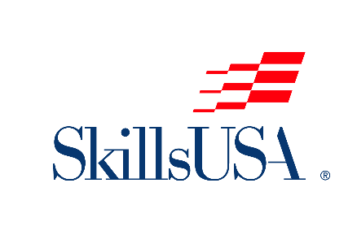
SkillsUSA is a partnership of students, teachers and industry working together to ensure America has a skilled workforce. SkillsUSA helps each student excel. We provide educational programs, events and competitions that support career and technical education (CTE) in the nation’s classrooms.

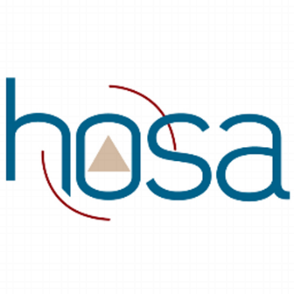
HOSA is a student organization whose two-fold mission is to promote career opportunities in the health care industry and to enhance the delivery of compassionate, quality health care by providing opportunities for knowledge, skill and leadership development of all health science education students. This is done through a program of motivation, awareness and recognition.
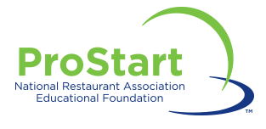
ProStart is one of the largest industry-supported career technical education programs in the nation, empowering students to achieve long term, successful careers in the restaurant and foodservice sector.

